**STYLE GUIDE**

**Heading 1 (Unwind/ Breathe):**

font-size: 80px

text-align: center

border-style: solid

font-family: 'EB Garamond', serif

**Navbar text:**

font-family: 'Lato', sans-serif

font-size: 30px

**Slide button text :**

font-family: 'EB Garamond', serif

Text-transform: uppercase

font-size: 15px

**Menu Text:**

font-size: 22px

font-family: 'EB Garamond', serif

text-align: center

**Dropdown menu:**

font-family: 'EB Garamond', serif

font-size: 16px

border: none

**Music Pictures Text:**

text-align: center

font-family: 'Lato', sans-serif

Font-size:12px

**Footer Text:**

text-align: center

font-family: 'EB Garamond', serif

**Navbar Links :**

font-size: 17px

font-family: 'EB Garamond', serif

**Popup:**

font-size: 18px

text-align: right

**Log-in Text (large):**

font-size: 24px

text-align: center

**Text Area for input:**

font-size: 15px

**Log-in Text (small):**

font-size: 13px

**COLORS**



**Navbar:**

#0B3667

#FFFFFF

**Menu:**

#0B3667

#FFFFFF

**Footer:**

#0B3667

#FFFFFF

(Unwind)

**Slide Button:**

#0B3667

#0B3667

#FFFF00

#FFFFFF

**Popup:**

#000000

#FFFFFF

**Play/Pause buttons:**

#FFFF00

#FFFFFF

**Music Images Overlay:**

#FFFFFF

**Social Media:**

#0B3667

#FFFF00

#FFFFFF

**Log-in section:**

#0B3667

#0B3667

#FFFF00

#FFFFFF

**ICONOGRAPHY**



#2E8B57

#90EE90

#B784A7

#FFFFFF

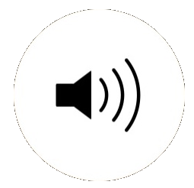



#000000

#FFFFFF



#FFFFFF

**Background images used:**

**On Unwind Page:**

<https://media2.giphy.com/media/LSjNnmhSQLdXW/source.gif>

**On Breathe Page:**

<https://i.pinimg.com/originals/ef/c6/d9/efc6d99cf4ac33217e661068775de927.gif>

**In Popup:**

<https://mindworks.org/wp-content/uploads/2018/01/What-is-zen-meditation_131588138.jpg>

Inhale/Exhale video used from <https://xhalr.com/>

**Video (Home page):**

<http://iwantfishing.com/images/vid.mp4>

**LAYOUT**

**Speakers:**

* Width: 40px;
* Position: absolute;
* Top: 280px;
* Left: 370px;
* Opacity: 0;
* Z-index: 1;

**Social-links:**

* Width: 25px;
* Height: 25px;
* Line-height: 25px !important;
* Position: relative;
* Margin: 2px 20px;
* Text-align: center;
* Display: inline-block;
* Top: 4px;
* Left: 9px;
* transition: all 0.27s cubic-bezier(0.300, 0.100, 0.580, 1.000);

**Slide Button:**

* Position: relative;
* Display: block;
* Height: 55px;
* Width: 170px;
* Margin: 10px 7px;
* Padding: 5px 5px;
* Letter-spacing: 2px;
* Border: 2px white solid;
* Border-radius: 4px;
* Overflow: hidden;
* Z-index: 1;
* Cursor: pointer;
* Transition: 0.08s ease-in;

**Popup :**

* Position: fixed;
* Left: 0;
* Top: 0;
* Height: 100%;
* Width: 100%;
* Opacity: 0;
* Visibility: hidden;
* Transition: opacity 0.3s 0s, visibility 0s 0.3s;

**Popup content:**

* Position: relative;
* Top: 12px;
* Padding-right: 10px;
* Margin: 30px 10px;
* Padding: 10px 30px;
* Line-height: 0.1em;
* Vertical-align: -0.4em;

**Dropdown:**

* Position: relative;
* Display: inline-block;

**Dropdown-content:**

* display: none;
* position: absolute;
* min-width: 160px;
* z-index: 1;

**Background-images:**

* position: relative;
* background-attachment: fixed;
* background-position: center;
* background-repeat: no-repeat;
* background-size: cover;

**Overlay on picture:**

* position: absolute;
* top: 0;
* left: 0;
* width: 100%;
* height: 100%;
* opacity: 0.3;

**Heading (Unwind, Home, and Breathe):**

* position: relative;

**Play Button:**

* width: 5px;
* padding-left: 4px;
* position: absolute;
* left: 70px;
* transition: .5s ease;
* opacity: 0;
* top: 50%;
* left: 50%;
* transform: translate(-50%, -50%);

**Video:**

* margin: 0 auto;
* min-width: 100%;
* min-height: 100%;
* width: auto;
* height: auto;
* z-index: -100;
* background-size: cover;
* transition: 1s opacity;

**Heading 1 (Unwind/ Breathe):**

* border-style: solid
* position: relative;
* padding-top: 200px;
* padding-right: 500px;
* padding-left: 500px;
* padding-bottom: 200px;

**Navbar text:**

* margin-left: 1180px;
* margin-top: 10px;

**Slide button :**

* position: relative;
* display: block;
* height: 55px;
* width: 170px;
* margin: 10px 7px;
* padding: 5px 5px;
* font-weight: 700;
* letter-spacing: 2px;
* border: 2px white solid;
* border-radius: 4px;
* outline: 0;
* overflow: hidden;
* background: none;
* z-index: 0;
* cursor: pointer;
* transition: 0.08s ease-in;

**Slide button arrow:**

* padding-left: 17px;
* content: "→";
* position: absolute;
* left: 83%;
* transition: all 250ms cubic-bezier(0.680, -0.550, 0.265, 1.550);
* opacity: 1;
* width: 170px;

**Slide button Content:**

* content: "Log into";
* position: absolute;
* transition: all 400ms cubic-bezier(0.680, -0.550, 0.265, 1.550);
* content: "Unwind →";
* height: 100%;
* width: 100%;
* position: absolute;
* opacity: 0;
* transition: all 500ms cubic-bezier(0.680, -0.550, 0.265, 1.550);
* left: 100%;

**Menu Text:**

* position: absolute;
* width: 310px;
* margin: -100px 0 0 0;
* padding: 50px;
* padding-top: 125px;
* right: -100px;
* height: 550px;
* transform-origin: 0% 0%;
* transform: translate(100%, 0);
* transition: transform 0.5s cubic-bezier(0.77, 0.2, 0.05, 1.0);

**Menu toggle:**

* position: absolute;
* top: 20px;
* right: 50px;
* z-index: 1;
* display: block;
* width: 40px;
* height: 32px;
* position: absolute;
* top: -7px;
* left: -5px;
* cursor: pointer;
* opacity: 0;
* z-index: 2;

**Menu Toggle which clicked:**

Hover effect when clicked to open:

opacity: 1;

transform: rotate(45deg) translate(-2px, -1px);

opacity: 0;

transform: rotate(0deg) scale(0.2, 0.2);

Hover effect when clicked to closed:

opacity: 1;

transform: rotate(-45deg) translate(0, -1px);

transform: scale(1.0, 1.0);

opacity: 1;

**Menu links:**

* padding-bottom: 50px;

**Dropdown menu:**

* position: relative;
* display: inline-block;

**dropdown-content :**

* position: absolute;
* min-width: 190px;
* min-height: 130px;
* z-index: 1;
* padding: 12px 16px;
* display: block;

**Music Pictures Text:**

* margin-bottom: -70px
* padding-top: 220px
* margin-left: 360px
* padding-bottom: 50px
* transition: .5s ease
* position: absolute
* top: 50%
* left: 50%
* transform: translate(-50%, -50%)

**Footer Text:**

* padding-bottom: 20px;
* top: 700px;
* left: 630px;
* position: absolute;

**Popup:**

* margin: 30px 10px;
* padding: 10px 30px;
* line-height: 0.1em;
* margin-right: 0.25em;
* vertical-align: -0.4em;
* max-height: 800px;
* margin: 10% auto auto auto;
* max-width: 500px;
* min-height: 100px;
* border-radius: 5px;
* margin: 10px;

**Log-in Text (large):**

* line-height: 1.2;
* width: 100%;
* display: block;
* padding-bottom: 30px;
* padding-top: 30px;

**Log-in text area:**

* width: 290px;
* position: relative;
* z-index: 1;
* margin-bottom: 10px;
* line-height: 1.5;
* display: block;
* width: 100%;
* height: 50px;
* border-radius: 25px;
* padding: 0 30px 0 68px;

**Placeholder:**

* display: block;
* position: absolute;
* border-radius: 25px;
* bottom: 0;
* left: 0;
* z-index: -1;
* height: 100%;
* width: 100%;

**Symbol in Log in boxes:**

* display: flex;
* position: absolute;
* border-radius: 25px;
* bottom: 0;
* left: 0;
* width: 100%;
* height: 100%;
* padding-left: 35px;
* transition: all 0.4s;

**ANIMATION**

**Animation for the Log-in form:**

animation: anim-shadow 0.5s ease-in-out forwards;

keyframes anim-shadow : box-shadow: 0px 0px 70px 25px;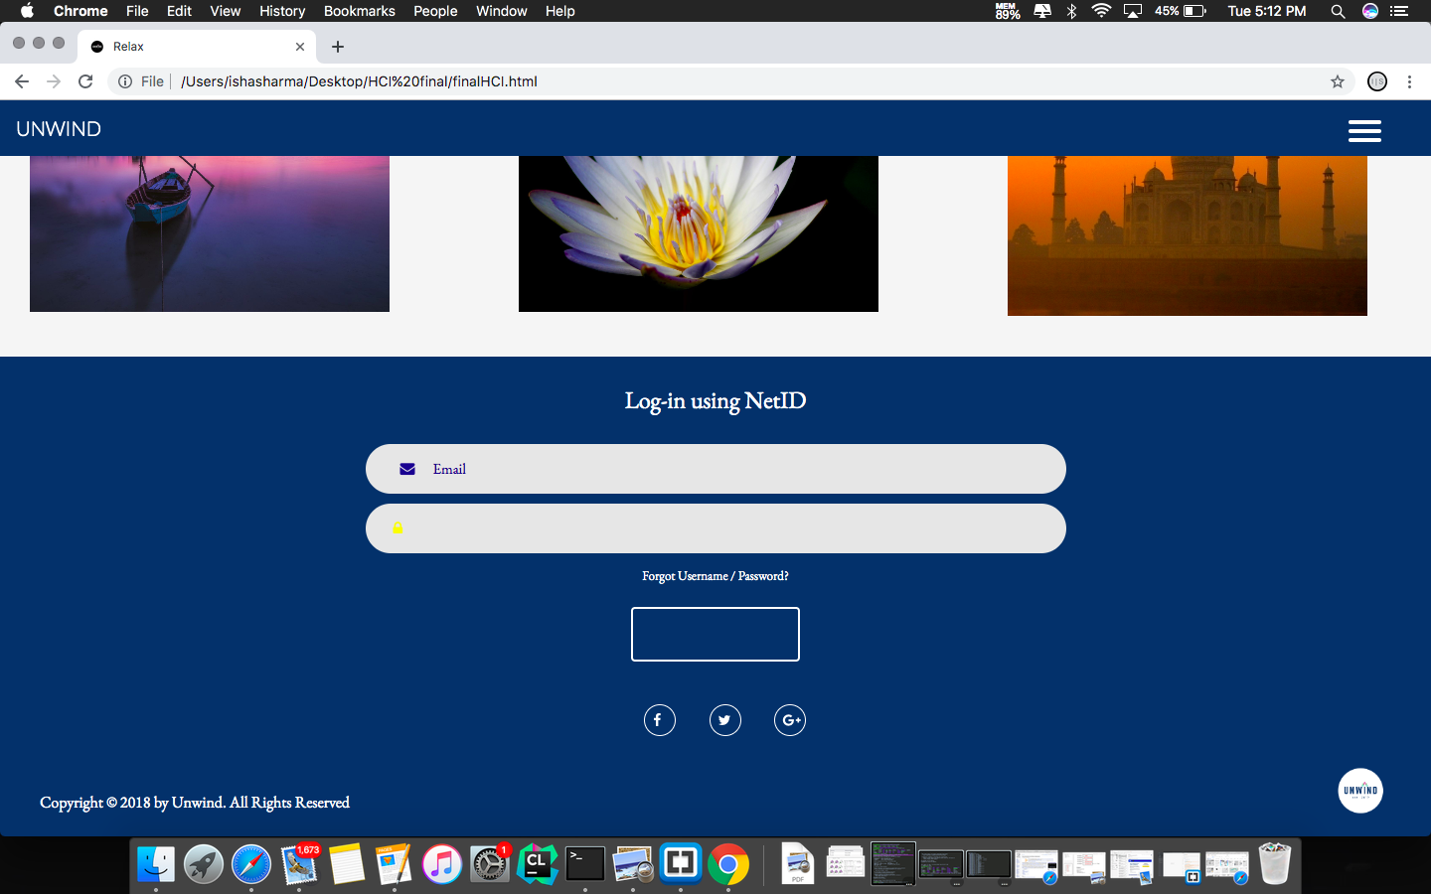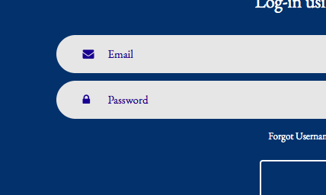

The reason why I'm using this transition with the login form is to give it a good inbuilt feedback, which would satisfy the user about they logging in to the website. Also, this effect is very sleek and it’s makes logging in easy for the people who have visual problems.

**Transition for the Social Media icons:**

transition: all 0.27s cubic-bezier(0.300, 0.100, 0.580, 1.000)

This transition is just to give a good feedback to the user when they hover over the social media icons. This transition also helps the people who are visually impaired to see that they interacted with the icon, and makes them aware about they will be directed to some other website. Also, this has colors from our preferred color scheme.

**Transition for the slide buttons:**

transition: 0.08s ease-in;

transition: all 400ms cubic-bezier(0.680, -0.550, 0.265, 1.550)

transition: all 500ms cubic-bezier(0.680, -0.550, 0.265, 1.550)

transition: all 425ms cubic-bezier(0.680, -0.550, 0.265, 1.550)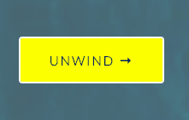

This transition

**Animation for the Log-in form:**

animation: anim-shadow 0.5s ease-in-out forwards;

keyframes anim-shadow : box-shadow: 0px 0px 70px 25px;

**Transition for Navbar:**

transition: 0.3s;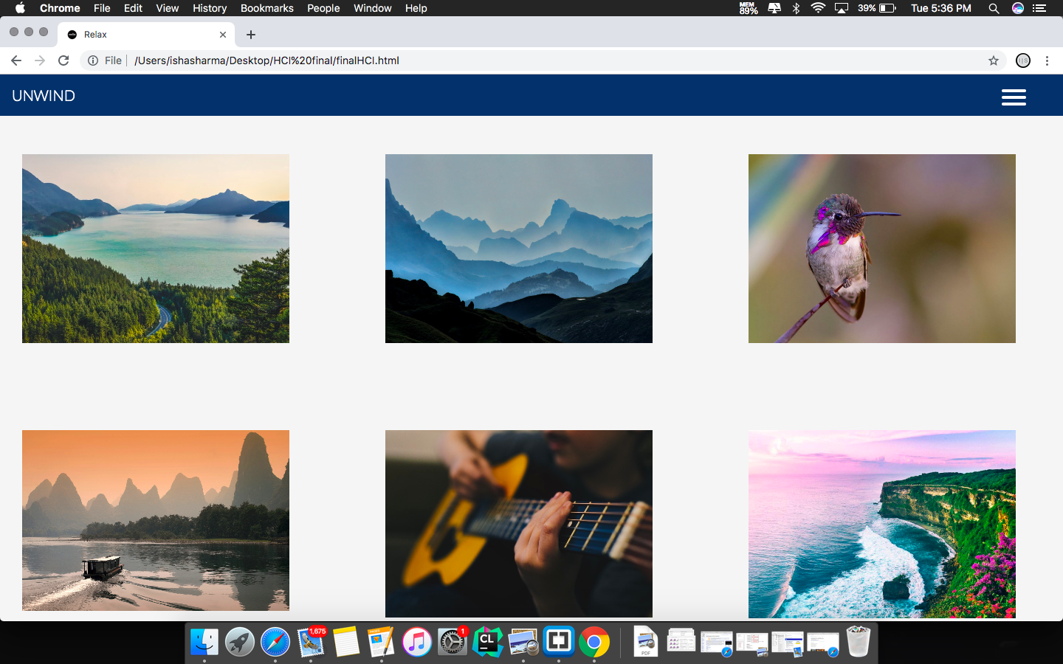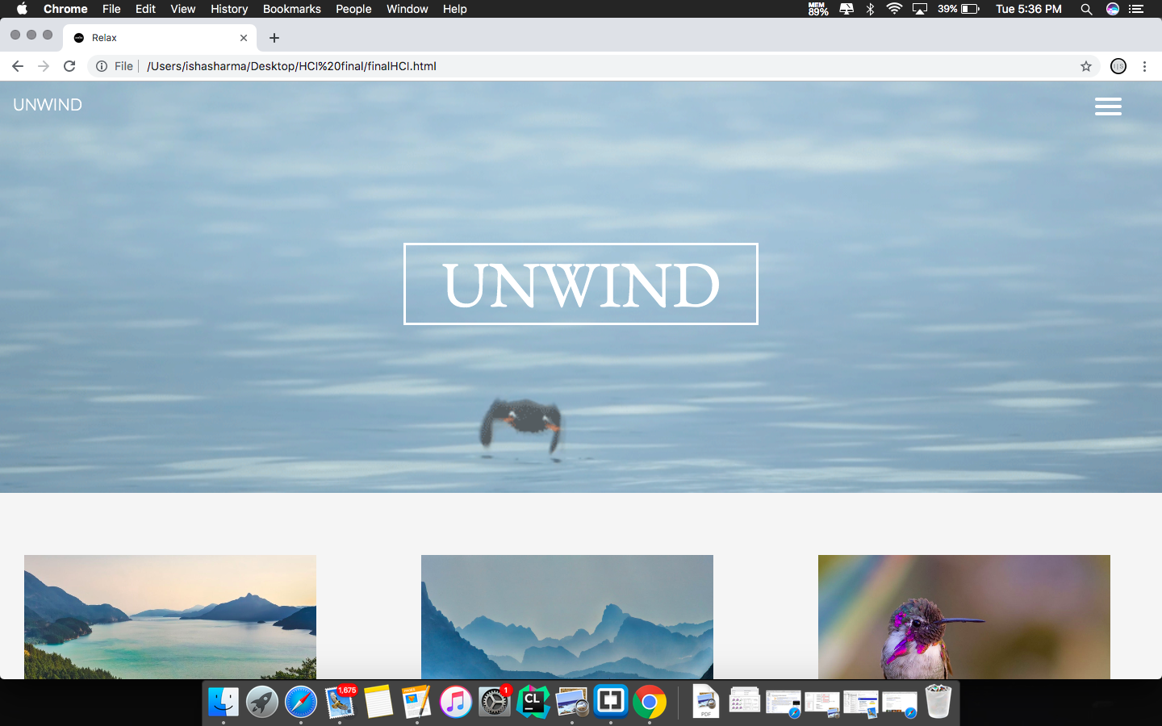

This transition helps the user to view the toggle menu and the name of the website clearly when they have scrolled down.

**Transition for Pop-up:**

transition: opacity 0.3s 0s, visibility 0s 0.3s;

transform: translateY(-40px);

transition-property: transform;

transition-duration: 0.3s;

**Transition for the Menu Toggle:**

transform-origin: 4px 0px;

transition: transform 0.5s cubic-bezier(0.77, 0.2, 0.05, 1.0), background 0.5s cubic-bezier(0.77, 0.2, 0.05, 1.0), opacity 0.55s ease;

transform: rotate(45deg) translate(-2px, -1px);

transform: rotate(0deg) scale(0.2, 0.2);

transform: rotate(-45deg) translate(0, -1px);

transform-origin: 0% 0%;

transform: translate(100%, 0);

transition: transform 0.5s cubic-bezier(0.77, 0.2, 0.05, 1.0);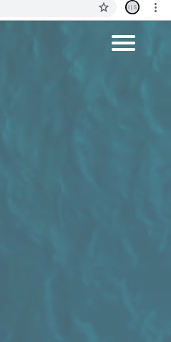

This transition is useful to view the menu and the contents of the website.

**Transition for the Overlay on music pictures:**

transition: .5s ease;

transform: translate(-50%, -50%);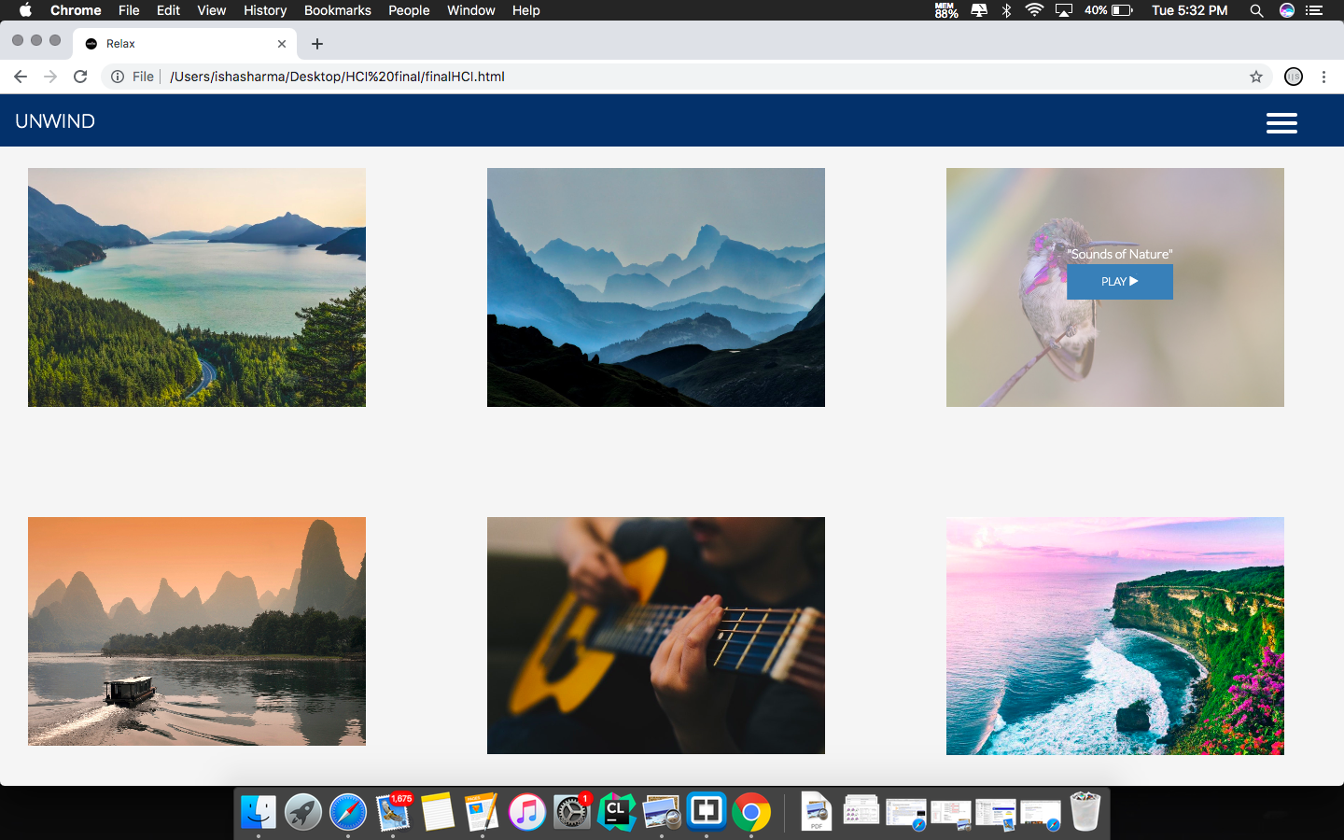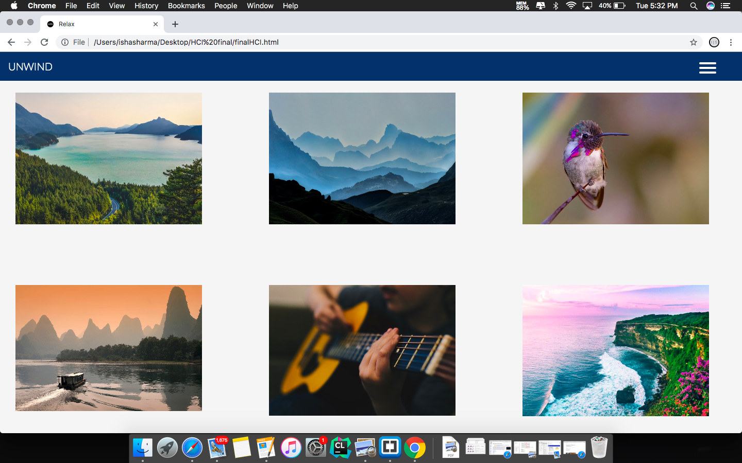

This transition is useful to view the overlay text box with the name of the soundtrack easily on the images used, as some of the names might blend with the picture, making it harder for the viewer to see the text.